The Status of Virginia’s Public Oyster Resource

2020

MELISSA SOUTHWORTH

and ROGER MANN

Molluscan Ecology Program

Department of Fisheries Science

Virginia Institute of Marine Science

The College of William and Mary

Gloucester Point, VA 23062

February 2021

TABLE OF CONTENTS
PART I. OYSTER RECRUITMENT IN VIRGINIA DURING 2020
INTRODUCTION 3
METHODS 4
RESULTS 5
James River 5
Piankatank River 7
Great Wicomico River 8
DISCUSSION 9

PART II. DREDGE SURVEY OF SELECTED OYSTER BARS IN VIRGINIA DURING 2020
INTRODUCTION 24
METHODS 25
RESULTS 26
James River 26
York River 27
Mobjack Bay 28
Piankatank River 28
Rappahannock River 28
Great Wicomico River 30
DISCUSSION 30

ACKNOWLEDGEMENTS 50
REFERENCES 50

Citation for this report:

Southworth, M. and R. Mann. 2021. The status of Virginia’s public oyster resource, 2020. Molluscan Ecology Program, Virginia Institute of Marine Science, Gloucester Point, Virginia. 51 pp.

Part I. OYSTER RECRUITMENT IN VIRGINIA DURING 2020

INTRODUCTION

The Virginia Institute of Marine Science (VIMS) monitors recruitment of the Eastern oyster, Crassostrea virginica (Gmelin, 1791), annually from late spring through early fall, by deploying spatfall (settlement and recruitment of larval oysters to the post metamorphic form termed spat) collectors (shellstrings) at various sites in three Virginia western Chesapeake Bay tributaries. The survey provides an estimate of a particular area’s potential for receiving a "strike" or settlement (set) of oysters on the bottom and helps describe the timing of recruitment events in a given year. Information obtained from this monitoring effort provides an overview of long-term recruitment trends in the lower Chesapeake Bay and contributes to the assessment of the current oyster resource condition and the general health of the Bay. These data are also valuable to parties on both the public side (Virginia Marine Resources Commission (VMRC), Conservation Replenishment Department) and private industry who are interested in potential timing and location of shell plantings in order to optimize recruitment of spat on bottom cultch (shell that is available for larvae to settle on).

Results from spatfall monitoring reflect the abundance of ready-to-settle oyster larvae in an area, and thus, provide an index of oyster population reproduction as well as development and survival of larvae to the settlement stage in an estuary. Environmental factors affecting these physiological activities may cause seasonal and annual fluctuations in spatfall, which are evident in the data.

Data from spatfall monitoring also serve as an indicator of potential oyster recruitment into a particular estuary. Survival of spat on bottom cultch is affected by many factors, including physical and chemical environmental conditions, the physiological condition of the larvae when they settle, predators, disease, and the timing of these various factors. Abundance and condition of bottom cultch also affects the settlement process and survival of spat on the bottom. Therefore, spatfall on shellstrings may not directly correspond with recruitment on bottom cultch at all times or places.

This report summarizes data collected during the 2020 settlement season in three tributaries in the Virginia portion of the Chesapeake Bay.

METHODS

Shellstrings are typically deployed by the third or fourth week of May. In 2020 however, initial deployment was delayed by several weeks due to the COVID 19 pandemic. Spatfall during 2020 was monitored in the Piankatank and Great Wicomico Rivers from the week of June 10 through the week of September 30, and in the James River from the week of June 17 through the week of September 30. Spatfall sites included eight historical sites in the James River, three historical and five modern sites in the Piankatank River and five historical and four modern sites in the Great Wicomico River (Figure S1). In this report, “historical” sites refer to those that have been monitored annually for at least the past twenty-five years, whereas “modern” sites are sites that were added during 1998 to help monitor the effects of replenishment efforts by the Commonwealth of Virginia. The modern sites in both the Piankatank and Great Wicomico Rivers correspond to those sites that were considered “new” in the 1998 survey. From 1993 through the early 2000s, VMRC built numerous artificial oyster shell reefs in several tributaries of the western Chesapeake Bay as well as in both Pocomoke and Tangier Sounds on the eastern side of the Chesapeake Bay. The change in the number and location of shellstring sites during 1998 was implemented to provide a means of monitoring oyster spatfall around some of these reefs. In particular, broodstock oysters were planted on a reef in the Great Wicomico River during winter 1996-97 and on reefs in the Piankatank and Great Wicomico Rivers during winter 1997-98. The increase in the number of shellstring sites during 1998 in the two rivers coincided with areas of new shell plantings in spring 1998 and provided a means of monitoring the reproductive activity of planted broodstock on the artificial oyster reefs. Since 1998, many of the reefs and bottom sites in the Piankatank and Great Wicomico Rivers have received shell plants on the bottom surrounding the reefs and these “new” sites have become permanent oyster spatfall monitoring sites.

Oyster shellstrings were used to monitor oyster spatfall. A shellstring consists of twelve oyster shells of similar size (about 76 mm, (3-in) in length) drilled through the center and strung (inside of shell facing the substrate) on heavy gauge wire (Figure S2). Throughout the monitoring period, shellstrings were deployed approximately 0.5 m (18-in) off the bottom at each site. Shellstrings were usually replaced after a one-week exposure and the number of spat that attached to the smooth underside of the middle ten shells was counted under a dissecting microscope. To obtain the mean number of spat shell⁻¹ for the corresponding time interval, the total number of spat observed was divided by the number of shells examined (ten shells in most cases). A manual with a step-by-step description of the shellstring survey methods used can be found on the VIMS/Molluscan Ecology website.

Although shellstring collectors at most sites were deployed for 7-day periods, there were some deviations such that shellstring deployment periods during 2020 ranged from 7 to 14 days. These periods do not always coincide among the different rivers monitored or in different years. Therefore, spat counts for different deployment dates and periods were standardized to correspond to the 7-day standard periods specified in Table 1 to allow for comparison among rivers and years. Standardized spat shell⁻¹ (S) was computed using the formula: S = ∑ spat shell⁻¹ / weeks (W) where W = number of days deployed / 7. Standardized weekly periods allow comparison of spatfall trends over the course of the season between various sites in a river as well as between data for different years.

The cumulative spatfall for each site was computed by adding the standardized weekly values of spat shell⁻¹ for the entire sampling period. This value represents the average number of spat that would fall on any given shell if allowed to remain at that site for the entire sampling period. Note that this assumes that the shell would remain clean and relatively unfouled by other organisms, which is typically not the case when shells are planted on the bottom. Spat shell⁻¹ values were categorized for comparison purposes as follows: 0.10-1.00, light; 1.01-10.00, moderate; 10.01 to 100.0, heavy; 100.01 or more, extremely heavy. Unqualified references to diseases in this text imply the two oyster diseases found in the bay, Haplosporidium nelsoni (MSX) and Perkinsus marinus (Perkinsus, or Dermo).

Water temperature (°C) and salinity (ppt) measurements were taken approximately 0.5 m off the bottom at all sites on a weekly basis using a handheld electronic probe (YSI Pro2030).

RESULTS

Spatfall on shellstring collectors during 2020 is summarized in Table S1 and is discussed below for each river system monitored. Table S2 includes a summary of spatfall compared with 2020 during the previous thirty years (1990-2019) at the historical sites in all three-river systems and during the previous twenty-two years (1998-2019) for the modern sites (as discussed in the methods) in the Piankatank and Great Wicomico Rivers. Unless otherwise specified, the information presented below refers to those two tables. In this report the term “peak” is used to define the period when there was a notable increase in spatfall at a particular site or area in the system compared with the other sites or when there was an increase at all sites throughout an entire river system.

When comparing 2020 data with historical data in the James River, all eight sites were used. All of the sites monitored in the James River are considered to be part of the traditional seed area. Historically seed oysters were transplanted from this area to other tributaries in the Chesapeake Bay where recruitment was typically low (Haven & Fritz 1985). Due to the addition of sites (modern) during 1998 in the Piankatank and Great Wicomico Rivers, any comparison made to historical data could not include data from all of the sites monitored during 2020. Comparisons were made over the past twenty-two years for the modern sites whereas the historical sites include thirty years of data. Historical sites in the Piankatank River are Burton Point, Ginney Point and Palace Bar. Historical sites in the Great Wicomico River include Fleet Point, Glebe Point, Haynie Point, Hudnall and Whaley’s East (labeled Cranes Creek in reports prior to 1997).

James River

Oyster spatfall in the James River was first observed during the week of June 24 at Swash, Dry Shoal, Rock Wharf and Wreck Shoal (Table S1). By the week of July 8, there was setting at all eight sites, with at least some settlement from then through the end of the monitoring period at each site every week, with the exception of July 22 at Rock Wharf and September 30 at Deep Water Shoal. Settlement in the James River during 2020 was not uniform across the river, with peaks occurring at different times at the various sites. However, looking at the river as a whole, there were three major peaks in spatfall during 2020. These were the weeks of July 8, August 5 and 12, and September 9. The combined total for those four weeks accounted for 72% of the settlement for the year in the James River (Table S1; Figure S3). Individual sites also experienced peaks that did not necessarily match the peaks observed in the river as a whole. For example, at Dry Shoal, 73% of the total settlement occurred during the weeks of August 8 and 15 and September 9. The three highest peaks at Wreck Shoal occurred during the weeks of July 8 and August 5 and 12, accounting for 65% of the total observed at that site.

Cumulative spatfall in the James River during 2020 was moderate at Deep Water Shoal, heavy at Horsehead, Point of Shoal, Swash, Rock Wharf, and Day’s Point and extremely heavy at Dry Shoal and Wreck Shoal. Spatfall varied widely from one site to the next, from a low of 9.7 cumulative spat shell⁻¹ at Deep Water Shoal to a high of 170.2 cumulative spat shell⁻¹ at Dry Shoal (Table S1; Figure S4). As noted in the methods section, the monitoring period in the James River during 2020 began approximately four weeks later than is typical. Despite this, spatfall during 2020 was higher than all previous reference points (2019, 5, 10, 20 and 30-yr means) at Horsehead, Dry Shoal and Wreck Shoal. Spatfall in 2020 was also higher than the previous year at Swash and higher than the 30-yr mean at Point of Shoal and Swash (Table S1; Figures S4). Comparing 2020 to the previous thirty years, spatfall numbers at Horsehead, Dry Shoal, and Wreck Shoal were the fifth, fifth, and fourth highest observed, respectively. Spatfall in 2020 at all eight sites ranked in the 63rd percentile or higher. The long-term means are primarily driven by a few exceptionally high spatfall years (1991, 1993, 2008, 2010, 2012, 2016, 2018 and 2019). Settlement over the past decade or so (2010 to 2020) throughout the James River, has been consistently moderate to heavy (Table S2).

Average river water temperature in the James River during the 2020 monitoring period ranged from a low of 21.3 to a high of 30.1°C (Figure S5A). Water temperature was several degrees lower than normal (Figure S5A) when monitoring first began in mid-June, but quickly increased and was 1 to 2°C higher than the long-term means (5, 10, 20 and 30-yr) for the four-week period between July 22 (when temperature reached the max for the year) and August 12 (Figure S5A). There was a fairly large decrease in temperature observed between the weeks of September 9 (26.9°C) and September 23/September 30 (20.6 and 21.3°C, respectively).

Average salinities in the James River during 2020 ranged from 5.0 to 15.2 ppt (Figure S5B), with several weeks showing fairly large fluctuations following large storm events. With the exception of the week of June 24, average salinity in 2020 was similar (< 3 ppt difference) to the 5, 10, 20 and 30-yr means from the beginning of the monitoring period through August 12 (Figure S5B). Between the weeks of August 12 and August 19, salinity decreased by almost 7 ppt and remained lower than normal (4 to 6 ppt less) for the rest of the monitoring period. The difference in salinity between the most upriver site (Deep Water Shoal) and the two most downriver sites (Day’s Point and/or Wreck Shoal; Figure 1) in any one week, ranged between 6 and 12 ppt.

Piankatank River

Spatfall in the Piankatank River was first observed during the week of June 17 at Ginney Point, Bland Point and Cape Toon (Table S1; Figure S6). Spatfall was variable for most of the monitoring period, with weekly sum totals for the entire river ranging from less than 1 to 41.9 spat shell⁻¹. Spatfall during the weeks of July 15 and July 22 accounted for 58% of the total spatfall observed during 2020. There was a second, smaller pulse observed from August 26 to September 16. This second four-week pulse accounted for 25% of the spatfall observed during the 2020 monitoring period.

Cumulative spat shell⁻¹ for the year was moderate at Wilton Creek, Palace Bar and Heron Rock and heavy at the other five sites monitored in the Piankatank River. Spatfall ranged from a low of 8.8 cumulative spat shell⁻¹ at Heron Rock to a high of 27.1 cumulative spat shell⁻¹ at Bland Point (Table S1; Figure S7). As noted in the methods section, the monitoring period in the Piankatank River during 2020 began approximately three weeks later than is typical. Spatfall during 2020 was lower than all previous reference points (2019, 5, 10, 20 and 30-yr means) at every site monitored. The one exception was Ginney Point, which had slightly higher spatfall in 2020 when compared with 2019, 25.9 cumulative spat shell⁻¹ in 2020 versus 24.3 in 2019. While some of this discrepancy may be explained by the shortened monitoring period, the fact that spatfall was absent to light during the first week of monitoring, suggests that the delay had little to no effect on the overall numbers observed. At the three historical sites, spatfall in 2020 was in the 53rd (Palace Bar), 66th (Ginney Point) and 70th (Burton Point) percentile over the past thirty years. At the modern sites, spatfall ranged from the 40th (Cape Toon and Stove Point) to the 54th (Bland Point) percentile since monitoring began at those sites in 1998.

The average water temperature during the 2020 sampling period in the Piankatank River ranged from 20.0 to 30.9°C, reaching the maximum in late July, as is typical for the river system (Figure S8A). Water temperature in the Piankatank River decreased approximately 3.5°C between the first and second week of sampling. Water temperature then steadily increased and was 1 to 3°C higher than the long-term (5, 10, 20 and 30-yr) means for most of July and early August. Toward the end of the monitoring period, water temperature again made a sharp decline (approximately 5°C) between the weeks of September 16 and September 23 (Figure S8A).

Salinity in the Piankatank River during 2020 ranged from 14.8 to 17.5 ppt (Figure S8B) and generally increased during the months of June and July. During this time, on average, salinity was around 1 higher than the long-term (5, 10, 20 and 30-yr) means. Between the weeks of August 5 and August 12, salinity decreased by 2 ppt and fluctuated between 15 and 17 ppt, throughout the rest of the sampling period. In any given week, during June and July, into early August, the difference recorded between the most upriver site (Wilton Creek) and the most downriver site (Burton Point; see Figure S1) ranged from a low of less than 1 ppt to a high of 2 ppt. From early to mid-August, this difference was between 4 and 6 ppt and was between 6 and 8 ppt during the last three weeks of the monitoring period. It should be noted that Wilton Creek is a shallow site (~1 m depth) and is strongly influenced by local rain events.

Great Wicomico River

Spatfall in the Great Wicomico River was first observed during the week of June 17 at all nine sites monitored. There was a very large pulse in spatfall during the three-week period between June 24 and July 8. Settlement during these three weeks accounted for 98 to 99% of the total for the year at every site except Fleet Point (Table S1; Figure S9A). At Fleet Point, this period accounted for 58% of the total, with an additional 26% occurring between September 2 and September 23 (Table S1; Figure S9B).

Cumulative spat shell⁻¹ for the year was extremely heavy at every site except Fleet Point and ranged from a low 23.9 at Fleet Point to a high of 1,177.7 at Rogue Point (Table S1; Figure S10). As noted in the methods section, the monitoring period in the Great Wicomico River during 2020 began approximately three weeks later than is typical. Spatfall in the Great Wicomico River in 2020 was higher than that observed at all previous reference points (2019, 5, 10, 20 and 30-yr means) at every site monitored except Fleet Point (Table S2). Spatfall at Fleet Point was lower than all previous reference points. Although spatfall had already started when shellstrings were deployed (as evidenced by some spatfall occurring during the first week of monitoring), the overall spatfall numbers for the year were exceptionally high and do not appear to have been affected by the delay in monitoring. When compared with the previous thirty years, spatfall in 2020 was the highest observed at Hudnall, the second highest at Haynie Point and Whaley’s East (96th percentile), the third highest at Glebe Point (93rd percentile) and the seventh highest at Fleet Point; (80th percentile). When compared to the previous twenty-two years, spatfall in 2020 at the four modern sites was the highest observed at Rogue Point and the second highest at Hilly Wash, Harcum Flats and Shell Bar (96th percentile). Spatfall on the shellstring collectors in the Great Wicomico River has been consistent and heavy in almost every year since 2006 (Table S2).

The average river water temperature in the Great Wicomico River during the 2020 sampling period ranged from 20.9 to 30.9°C, reaching the maximum in late July, as is typical for the river system (Figure S11A). Water temperature in the Great Wicomico River decreased by almost 4°C between the first and second week of sampling. Water temperature then steadily increased and was 1 to 3°C higher than the long-term (5, 10, 20 and 30-yr) means from late July through early August. Toward the end of the monitoring period, water temperature again made a sharp decline (approximately 4°C) between the weeks of September 16 and September 23 (Figure S11A).

Salinity in the Great Wicomico River during the 2020 sampling period remained relatively stable, ranging between 13.6 and 16.5 ppt (Figure S11B). Salinity in 2020 was slightly higher (1-2 ppt difference) than the long-term (5, 10 and 20-yr) means throughout most of July, but was similar to the long-term means for most of the rest of the monitoring period (Figure S11B). In any given week, there was typically a 1 to 3 ppt difference in salinity between the most upriver site (Glebe Point) and the most downriver site (Fleet Point: Figure S1).

DISCUSSION

During the fourteen-year period between 1994 and 2007, spatfall on the shellstrings was light to moderate; with 83% of all of the year/site combinations having a seasonal cumulative total of less than 10 spat shell⁻¹. However, spatfall on the shellstrings over the past thirteen years (2008-2020) has been on the rise such that 85% of all of the year/site combinations had heavy spatfall (seasonal cumulative total of > 10 spat shell⁻¹) and 34% of all of the year/site combinations had extremely heavy spatfall (seasonal cumulative total of > 100 spat shell⁻¹; Table S2). This trend of increased spat set has been especially notable in the Great Wicomico River, where from 2006 through 2020, 87% of all of the year/site combinations had heavy spatfall (seasonal cumulative total of > 10 spat shell⁻¹) and 52% of the total year/site combinations had extremely heavy spatfall (seasonal cumulative total of > 100 spat shell⁻¹; Table S2).

During 2020, there were periods when the water temperature in all three river systems, and salinity in the James River, deviated from the norm by a notable amount. The first temperature deviation occurred in early June. Local air temperatures during this time dipped below the high average for a six-day period and below the low average for one day. This resulted in a fairly large (3-4°C) decrease in water temperature in all three rivers. A second deviation occurred in mid to late September when both the daily high and low air temperatures were well below the average. This also resulted in a fairly large (4-5°C) decrease in water temperature in all three rivers. Salinity in the James River was lower than the long-term means from mid-August through the end of the monitoring period. Rainfall data from Richmond (which is located near the fall line of the James River) during this time period, shows much higher amounts than is typical for that time of year, thus resulting in lots of fresh water flowing downriver.

Overall, spatfall on shellstrings in the James River during 2020 was heavy to extremely heavy. The one exception was moderate spatfall at Deep Water Shoal. Since 2008, the James River has had several very strong year classes, 2008, 2010, 2012, 2016, 2017, 2018 and now 2020. The mean cumulative spat shell⁻¹ over all eight sites from 1994 to 2007 was 5.7, whereas the mean for all eight sites over the past thirteen years (2008 to 2020) was 77.3. This translates to around a thirteen-fold increase in spatfall over the past thirteen years compared with the previous fourteen years. Since 2008, at least three out of the eight sites experienced heavy to extremely heavy spatfall each year, with heavy or extremely heavy spatfall during 80% (83/104) of the year/site combinations and moderate spatfall during the remaining year/site combinations (21/104). The one exception was during 2009, when all eight sites monitored had moderate spatfall (Table S2). From 1994 to 2007 on the other hand, only 16% (18/112) of the year/site combinations had heavy or extremely heavy spatfall, with 16% (18/112) during that time period experiencing light spatfall. The majority of the spatfall in 2020 occurred in four separate weeks, one in early July, two in early to mid-August and one in early September.

Overall, spatfall in 2020 on the shellstrings in the Piankatank River was moderate to heavy on all eight sites monitored. Similar to the James River, the Piankatank River has had several very strong year classes in recent years (2012, 2014, 2015 and 2016). From 1994 to 2006 (historical sites) and 1998 to 2006 (modern sites), spatfall in the Piankatank River was consistently low to moderate at most of the sites monitored. Spatfall began to improve beginning around 2007 and has been consistently good since 2010. From 1994 to 2009, only 15% (16/108) of the year/site combinations experienced heavy spatfall and 32% (35/108) experienced light spatfall. However, since 2010, only four year/site combinations have had moderate spatfall, with extremely heavy spatfall at 25% (22/88) of the year/site combinations and heavy spatfall during the remaining year/site combinations. At the three historical sites the mean from 1994 to 2009 was 3.3 cumulative spat shell⁻¹, whereas from 2010 to 2020 the mean at those three sites was 74.8 cumulative spat shell⁻¹, a 23-fold increase over the previous sixteen-year mean. Since the addition of the modern sites in 1998, the mean across the river increased from 5.5 cumulative spat shell⁻¹ (1998 to 2009) to 88.2 cumulative spat shell⁻¹ (2010 to 2020), a 16-fold increase.

With the exception of 2018, spatfall on the shellstrings in the Great Wicomico has been especially good since 2006. Three out of the last five years (2016, 2017 and 2019) saw extremely heavy spatfall at all nine sites monitored in the Great Wicomico River. In seven out of the nine years between 2012 and 2020, at least seven of the sites monitored in the Great Wicomico had extremely heavy spatfall each year. As has been typical in recent years (Southworth & Mann 2004), spatfall in the Great Wicomico has been getting progressively earlier, with the majority (greater than 98%) of spat settling on the shellstrings in 2020, having set by early July.

Table S1: Average number of spat shell⁻¹ for standardized week beginning on the date shown. “D” indicates the date deployed and “-“ denotes a week when a shellstring was not collected.

Table S2: Spatfall totals for historical sites (1990-2020) and modern sites (1998-2020) as defined in the text. Values presented are the
cumulative sum of spat shell⁻¹ values for each year. “+” and “-“ indicate the direction of change in 2020 in reference to 2019 and to the
five, ten, twenty, and thirty year means. Blank cells for a site indicate years where data are not available.

Figure S1: Map showing the location of the 2020 shellstring deployment sites. An M following the site name indicates a modern site as specified in the text; all other sites are historical. James River: 1) Deep Water Shoal, 2) Horsehead, 3) Point of Shoal, 4) Swash, 5) Dry Shoal, 6) Rock Wharf, 7) Wreck Shoal, 8) Day’s Point. Piankatank River: 9) Wilton Creek (M), 10) Ginney Point, 11) Palace Bar, 12) Bland Point (M), 13) Heron Rock (M), 14) Cape Toon (M), 15) Stove Point (M), 16) Burton Point. Great Wicomico River: 17) Glebe Point, 18) Rogue Point (M), 19) Hilly Wash (M), 20) Harcum Flats (M), 21) Hudnall, 22) Shell Bar (M), 23) Haynie Point, 24) Whaley’s East, 25) Fleet Point.

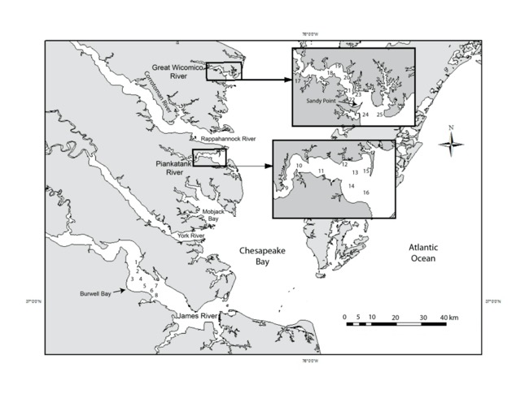
Figure S2: Diagram of the shellstring setup on buoys with pictures laying out each step (see https://www.vims.edu/research/units/labgroups/molluscan_ecology/_docs/Shellstring_manual.pdf for a detailed description of shellstring survey methods).

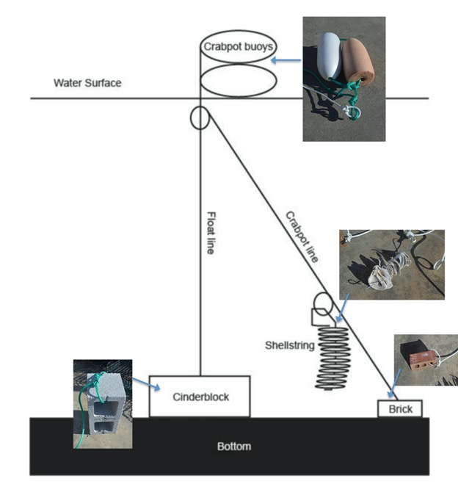

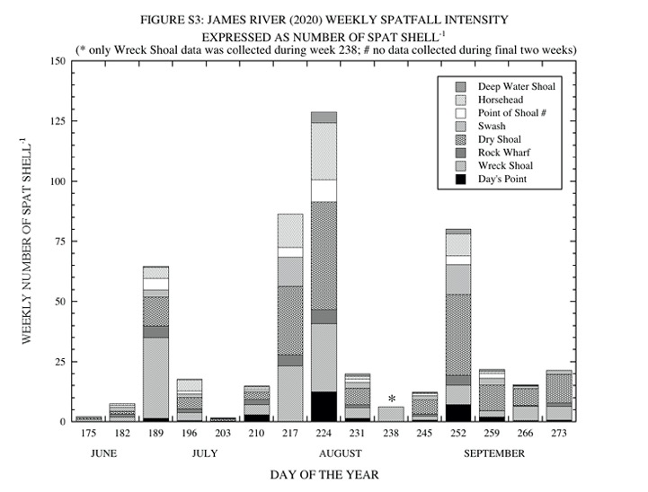

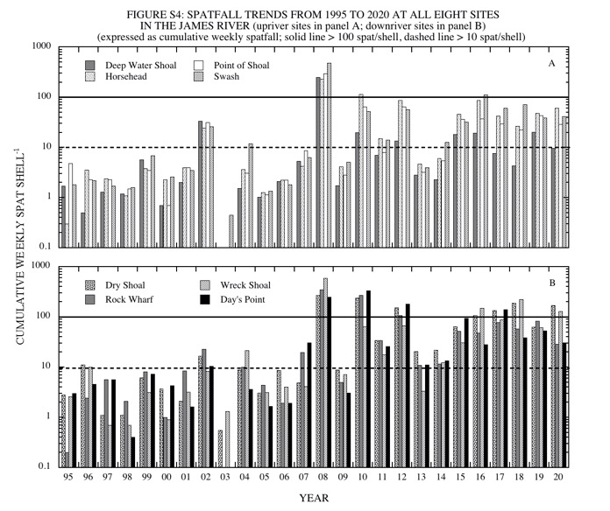

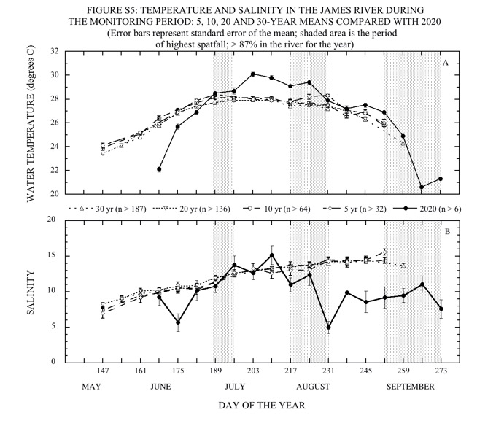

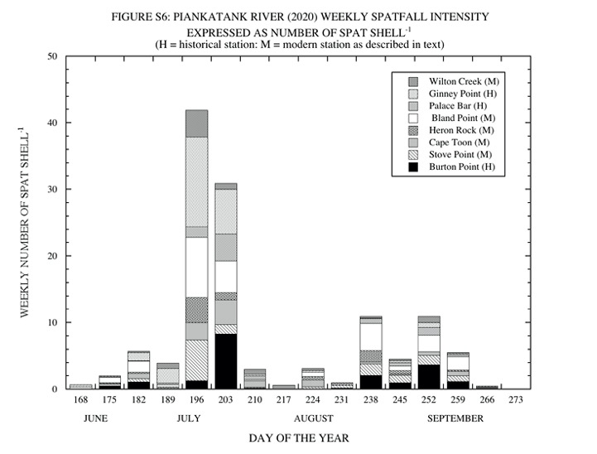

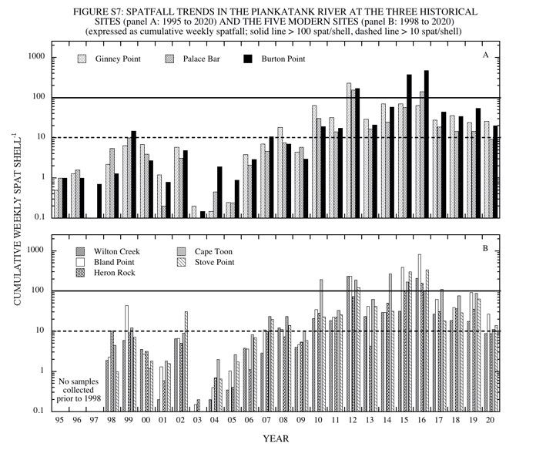

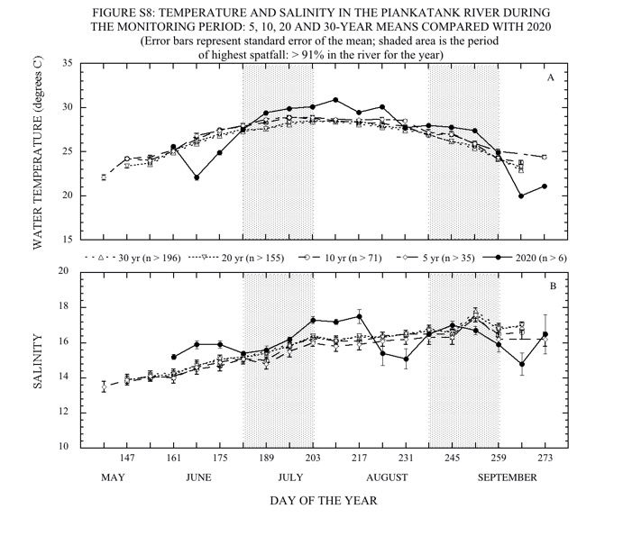
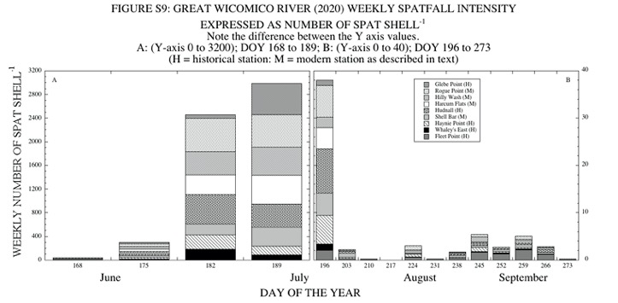

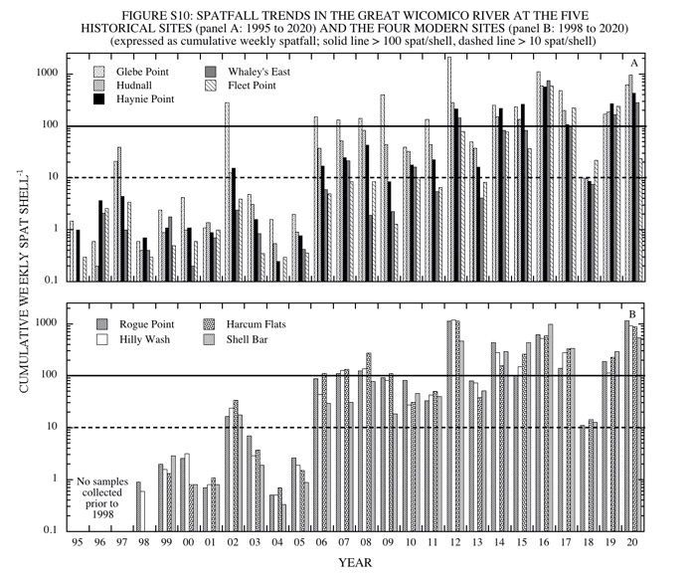
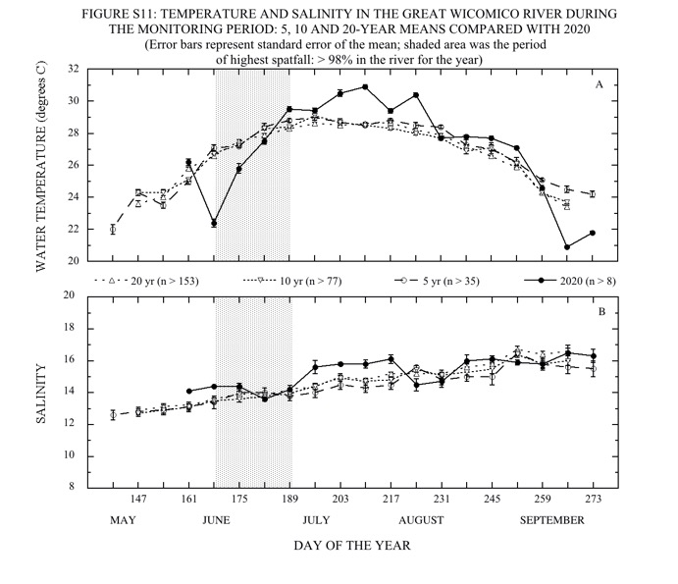

Part II. DREDGE SURVEY OF SELECTED OYSTER BARS IN VIRGINIA DURING 2020

INTRODUCTION

The Eastern oyster, Crassostrea virginica (Gmelin, 1791), has been harvested from Virginia waters as long as humans have inhabited the area. Accelerating depletion of natural stocks during the late 1880s led to the establishment of oyster harvesting regulations by public fisheries agencies. A survey of bottom areas in which oysters grew naturally was completed in 1896 under the direction of Lt. J. B. Baylor, U.S. Coast and Geodetic Survey (Baylor 1896) and was later updated by Haven et al. (1981). These areas (over 243,000 acres) were set aside by legislative action for public use and have come to be known as the Baylor Survey Grounds or Public Oyster Grounds of Virginia. These areas are presently under management by the Virginia Marine Resources Commission (VMRC).

Every year the Virginia Institute of Marine Science (VIMS) in collaboration with VMRC, conducts a dredge survey of selected public oyster bars in Virginia tributaries of the western Chesapeake Bay to assess the status of the existing oyster resource. These surveys provide information about oyster recruitment, mortality, and relative changes in abundance of seed and market-size oysters from one year to the next. This section summarizes data collected during oyster bar surveys conducted during September and October 2020.

Spatial variability in the distribution of oysters over the bottom can result in wide differences among dredge samples. Large differences among samples collected on the same day from one bar are an indication that distribution of oysters over the bottom is highly variable. An extreme example of that variability can be found in Figure D2 of the 2015 annual report (Southworth & Mann 2016) by the width of the confidence interval around the average count of spat (average spat count = 1033.5, CI = 524.0) at Deep Water Shoal (James River, VA). Dredges provide semi-quantitative data, have been used with consistency over extended periods of time (decades) in Virginia, and provide data on population trends. However, absolute quantification of dredge data is difficult in that dredges accumulate organisms as they move over the bottom, may not sample with constancy throughout a single dredge haul, and may fill before completion of the haul, thereby providing biased sampling (Mann et al. 2004). Therefore, in the context of the present sampling protocol, differences in average counts found at a particular bar in different years may be the result of sampling variation rather than actual short-term changes in abundance. If the observed changes persist for several years and/or can be attributed to well-documented physiological or environmental factors, then they may be considered a reflection of actual changes in abundance with time.

METHODS

Locations of the oyster bars sampled during Fall 2020 are shown in Figure D1. Geographic coordinates of the bars are given in Table D1. It should be noted that the 2020 dredge survey was conducted approximately 2 to 3 weeks earlier (mid to late September versus early to mid-October) than it usually is to account for the restrictions placed on personnel due to the COVID 19 pandemic.

Samples of bottom material were collected on each bar using an oyster scrape/dredge. In all surveys in the York River and Mobjack Bay (through 2020) and in the Great Wicomico River in 2015, samples were collected using a 2-ft wide oyster scrape with 4-in teeth towed from a 21-ft boat; volume collected in the scrape bag was 1.5 bushels. For clarification, all bushels mentioned in this report refer to a Virginia bushel (3003.9 inches³), which differs from a US bushel (2150.4 inches³) and a Maryland bushel (2800.7 inches³). In the James, Piankatank, Rappahannock, and Great Wicomico River, samples (with the exception of 2015 in the Great Wicomico River as previously mentioned) were collected using a 4-ft oyster dredge with 4-in teeth towed from the 43-ft long VMRC research vessel J. B. Baylor; volume collected in the bag of that dredge was 3 bushels. In all surveys a half-bushel (25 liters) subsample was taken from each tow for examination. Data presented give the average of the samples collected at each bar for live oysters and box counts after conversion to a full bushel. In most years, four samples (n = 4) were collected and processed at each sampling site, however, some deviation did occur such that fewer samples were collected. Due to the large number of oysters observed in the 2020 samples in the James River, the number of samples was reduced (n = 3) at all of the sites to facilitate sample processing in a timelier manner. The number of samples was also reduced at both Mobjack Bay sites (n = 3) and at Ross Rock and Long Rock in the Rappahannock River (n = 2).

From each half-bushel sample, the number of market oysters (76 mm = 3-in. in length or larger), small oysters (< 76 mm, excluding spat), spat (recent 2020 recruits), new boxes (inside of shells perfectly clean; presumed dead for approximately < 1 week), old boxes, spat boxes and drill boxes (spat box with a drill hole, indicative of predation by one of the two native oyster drills, Eupleura caudata and Urosalpinx cinerea, both of which are found in the Chesapeake Bay) were counted. The presumed time period since death of an oyster associated with the new and old box categories is a qualitative description based on visual observations. Water temperature (°C) and salinity (ppt) were recorded approximately 0.5 meters off the bottom on the day of sampling at each of the oyster bars using a handheld electronic probe (YSI 30).

RESULTS
Thirty oyster bars were sampled between September 16 and October 1, in six of the major Virginia tributaries on the western shore of the Chesapeake Bay. Bar locations and geographic coordinates are shown in Figure D1 and Table D1, respectively. It should be noted that Bell Rock in the York River is located on a private lease and is included in this report for historical reasons. Results of this survey are summarized in Table D2 and, unless otherwise indicated, the numbers presented below refer to that table. In years where data was not collected for a specific site, it has been indicated on the graph for that particular site/system. All other blanks on the graphs are where the population levels for a particular site/oyster category were zero.

James River

Ten bars were sampled in the James River, between Nansemond Ridge at the lower end of the river and Deep Water Shoal near the uppermost limit of oyster distribution in the system. The average number of live oysters ranged from a low of 196.0 bushel⁻¹ at Nansemond Ridge to a high of 4,064.3 bushel⁻¹ at Mulberry Point. The total number of live oysters was the highest observed over the past twenty-five years of monitoring at Mulberry Point, the third highest observed at Point of Shoal, Swash, Long Shoal, Wreck Shoal and Thomas Rock and the fourth highest at Horsehead and Deep Water Shoal (Figure D2). When spat are excluded, the total number of small and market oysters combined was the highest (Mulberry Point, Horsehead, Point of Shoal, Swash, Long Shoal and Wreck Shoal), second highest (Thomas Rock) and third highest (Deep Water Shoal and Nansemond Ridge) observed over the past twenty-five years. The number of oysters at Nansemond Ridge had been at fairly low levels for several years, but has generally been increasing, such that 2020 was the third highest observed over the past twenty-five years in small oysters and the highest observed in market oysters (Figure D2C).

The average number of market oysters in the James River remains low when compared with historical numbers. The number of market oysters in 2020 ranged from a low of 1.3 bushel⁻¹ at both Deep Water Shoal and Mulberry Point to a high of 104.0 bushel⁻¹ at Point of Shoal. There was a small, but notable increase in the number of market oysters at Point of Shoal when compared with 2019 (Figure D3). The number of market oysters at Point of Shoal has fluctuated from one year to the next for the past several years, it was up in 2015, down in 2016 and 2017, then back up in 2018, 2019 and 2020. This reef has been heavily targeted for seed harvest over the past few years and this fluctuation may reflect that activity. The number of market oysters at Wreck Shoal steadily increased between 2009 and 2014, then remained relatively stable (between 90 and 100 bushel⁻¹) from 2014 to 2016 (Figure D2C). The number of market oysters on Thomas Rock has remained relatively stable for the past five years, ranging between 51 and 66 bushel⁻¹ (Figure D2C). For the fifth year in a row, the number of market oysters at Mulberry Point and Swash were among the lowest observed (the lowest and third lowest, respectively) since monitoring began at those sites in the early 1990s (Figures D2A and D2B). The number of market oysters on Deep Water Shoal, remains low (second lowest over the past twenty-five years), following the 2018 low salinity mortality event.

The average number of small oysters bushel⁻¹ ranged from a low of 104.0 at Nansemond Ridge to a high of 3,716.0 at Mulberry Point. When compared with 2019, there was a notable increase in the number of small oysters at Mulberry Point and Point of Shoal and a notable decrease at Thomas Rock (Figures D2 and D3). With these increases, 2020 had the highest number of small oysters over the past twenty-five years at Mulberry Point and Point of Shoal, as well as at Long Shoal. The number of small oysters in 2020 was the second highest at Horsehead, Wreck Shoal and Thomas Rock and the third highest at Deep Water Shoal and Swash. While the number of small oysters observed at Nansemond Ridge was the lowest of the ten sites, 2020 numbers were similar to those observed in 2018 and 2019, which were twice as high as any of the previous twenty-four years (Figure D2C).

Overall, recruitment in the James River in 2020 was moderate, and generally lower than that observed over the past few years (Figure D2). There was a notable decrease observed when compared to 2019 at all ten sites monitored (Figures D2 and D3). The average number of spat bushel⁻¹ ranged from a low of 53.3 at Nansemond Ridge to a high of 691.7 at Swash. Since 2008, recruitment in the James River has had several strong year classes; 2008, 2010, 2012, 2015, 2016, 2018 and 2019. This is in contrast to what was observed on the shellstrings (Part I of this report), where 2015 and 2019 were moderate years, but 2017 and 2020 were good years.

The average number of boxes bushel⁻¹ was low to moderate, ranging from 23.3 at Nansemond Ridge to 62.7 at Wreck Shoal, and was generally higher at the mid-river sites. Boxes accounted for less than 5% of the total (live oysters plus boxes) at every site except Nansemond Ridge, with the majority old boxes. At Deep Water Shoal, 27% of the boxes were spat boxes and 19% were new boxes, indicating some recent mortality at that site.

Water temperature during the two days of sampling ranged between 20.7 and 21.5°C (Table D2). This was similar to what the temperature normally is during the survey, despite the survey being approximately two weeks earlier than normal. Salinity generally increased in a downriver direction (see Figure D1), from a low of 3.5 ppt at Deep Water Shoal to a high of 14.1 ppt at Nansemond Ridge.

York River

In the York River, the average total number of live oysters bushel⁻¹ was 349.5 at Bell Rock and 469.5 at Aberdeen Rock. When compared with 2019, there was a notable increase in the number of both small and market oysters observed at both sites (Figures D4 and D5) and a notable decrease in the number of spat. The number of market oysters at Aberdeen Rock has been steadily increasing over the past six years (Figure D5) such that 2020 had the highest number observed over the past twenty-five years. At both sites in the York River, recruitment was light and the number of small and market oysters combined was the highest observed over the past twenty-five years. The average number of boxes bushel⁻¹ was relatively high at Bell Rock and low at Aberdeen Rock, accounting for approximately 17 and 5% of the total (live oysters plus boxes), respectively. This is in contrast to the previous four years when Bell Rock had a relatively low number of boxes compared with Aberdeen Rock. The majority (>98%) of the boxes at both sites were old. Water temperature on the day of sampling was around 20.5°C at both sites. Salinity was 9.1 ppt at Bell Rock and 14.1 ppt at Aberdeen Rock.

Mobjack Bay

The average total number of live oysters at Tow Stake and Pultz Bar were 1,290.6 and 721.3 oysters bushel⁻¹, respectively. When compared with 2019, there was a notable increase in the number of small oysters at both sites and an increase in market oysters at Pultz Bar (Figure D4). There was also a very large decrease in the number of spat at both sites. Recruitment in 2019 at Pultz Bar was almost four times higher than the next highest observed between 1994 and 2019, but comparatively few (around 13%) of these remained as small oysters in 2020 (Figure D6). Despite this, 2020 still had the second highest number of small oysters observed over the past twenty-five years. The number of small oysters at Tow Stake was the highest observed over the past twenty-five years, almost five times higher than the next highest year. The total number of boxes observed in the system was low, accounting for 2% of the total (live oysters plus boxes) at both sites. All of the boxes observed at both sites were old. On the day of sampling, water temperature was around 20°C at Pultz Bar and 19°C at Tow Stake. Salinity was 18.6 ppt at both sites. There were no drill boxes observed at either site.

Piankatank River

In the Piankatank River, the average total number of live oysters bushel⁻¹ ranged from a low of 545.0 at Ginney Point to a high of 872.0 at Burton Point. When compared with 2019, there was a notable decrease in the number of spat at all three sites (Figures D7 and D8). Overall, the number of market oysters in the river was low from 1993 through 2007, but generally increased between 2008 and 2014. Since 2014, there have generally been more market oysters in the Piankatank River but numbers from one year to the next have been more variable. The same is true for small oysters. The average number of market oysters from 1995 to 2007 across all three sites was 5.7 bushel⁻¹, whereas from 2008 to 2020 the average was 48.3 bushel⁻¹. For small and market oysters combined the average from 1995 to 2007 was 79.1 bushel⁻¹, whereas from 2008 to 2020, the average was 317.0 bushel⁻¹. Recruitment in 2020 was relatively low at all three sites, with the overall average across the three sites ranking in the 40th percentile over the past twenty-five years. The recruitment numbers observed in the dredge survey was consistent with what was observed in the shellstring survey (Part I of this report). The number of boxes observed was low at all three sites, accounting for 2 (Palace Bar and Burton Point) to 3% (Ginney Point) of the total (live plus dead). The majority (>85%) of boxes at all three sites were old. On the day of sampling, water temperature was around 20ºC at all three sites and salinity was between 12.0 (Ginney Point) and 13.9 ppt (Burton Point). There were no drill boxes observed at any of the sites.

Rappahannock River

In the Rappahannock River, the average total number of live oysters bushel^{–1} ranged from a low of 4.0 at Ross Rock (which experienced 100% mortality during the summer of 2018 due to a freshet) to a high of 605.0 at Middle Ground. As is typical for the Rappahannock River system, there appeared to be no relationship between the total number of live oysters and location in the river (i.e., upriver vs. downriver: Figure D1), temperature or salinity (Table D2). Typically, most of the oysters in the Rappahannock River system are found in the Corrotoman River (Middle Ground), just outside the mouth of the Corrotoman (Drumming Ground) and at the more downriver sites. This pattern again held true during 2020. At Ross Rock, the oyster population had been steadily increasing since about 2009, but following a freshet event in 2018, all of the oysters at Ross Rock died. As of fall 2020, there were a few oysters at Ross Rock, but the population remains very low. The total number of oysters at Middle Ground showed a relatively large decrease in 2011, following several good years of growth between 2008 and 2010. Since then, the total number of oysters at Middle Ground has increased, such that numbers over the past few years have been greater than or similar to those observed prior to the decrease in 2011. The total number of oysters on Middle Ground in 2020 was at the highest level observed over the past twenty-five years of monitoring.

The average number of market oysters bushel⁻¹ ranged from a low of 0.0 at Ross Rock to a high of 97.0 at Broad Creek. When compared with 2019, there was a notable increase in the number of market oysters at Morattico Bar and Smokey Point (Figures D9 and D10). It should be noted that both Morattico Bar and Smokey Point received seed plants in the spring of 2019 and 2020 and Hog House received one in the spring of 2019. Evidence of these seed plants were found in at least one of the samples at both Morattico Bar and Smokey Point. The numbers of market oysters in 2020 were the highest observed over the past twenty-five years at Broad Creek and the second highest observed at Smokey Point and Middle Ground. Overall, the number of market oysters in the Rappahannock River has been higher since about 2008 (Figure D10). From 1995 to 2007, the average over all ten sites in any given year was less than 20 market oysters bushel⁻¹, whereas from 2008 to 2020 the average over all ten sites ranged between 22 (2008) and 70 (2016) market oysters bushel⁻¹ (Figure D10). The average over all nine sites (Ross Rock has not been included in the calculations since the 2018 mortality event) in 2020 was 41.7 market oysters bushel⁻¹.

The number of small oysters bushel⁻¹ ranged from a low of 1.0 at Ross Rock to a high of 499.5 at Middle Ground (Figures D9 and D10). When compared with 2019, there was a notable increase in the number of small oysters observed at Bowler’s Rock, Long Rock, Morattico Bar, Hog House, Middle Ground and Broad Creek (Figures D9 and D10). Again, it should be noted that Morattico Bar and Smokey Point both received seed plants in the spring of 2019 and 2020 and Hog House received one in the spring of 2019. At every site except Ross Rock, the number of small oysters observed in 2020 ranked among the highest to third highest observed over the past twenty-five years.

Overall, recruitment in the Rappahannock River in 2020 was generally light, ranging from 3.0 spat bushel^{–1} at Ross Rock to 91.0 spat bushel^{–1} at Parrot Rock. In recent years, recruitment has become more common at the more upriver sites (Figures D9 and D10) and while 2020 recruitment overall was relatively low, at least one spat observed at each of the ten sites monitored. In general, since 2010, higher recruitment has become more common in the Rappahannock River. In the fifteen-year period from 1995 to 2009, there were only four years (1995, 1999, 2002 and 2006) with an overall average recruitment greater than 50 spat bushel^{–1}, whereas in the eleven-year period from 2010 to 2020 there were five years (2010, 2012, 2015, 2017 and 2019) with an overall average recruitment greater than 50 spat bushel^{–1}, with higher recruitment occurring approximately every two to three years.

The average total number of boxes bushel⁻¹ was low, accounting for 1 (Morattico Bar) to 6% (Drumming Ground) of the total (live oysters plus dead). The one exception was at Ross Rock, with around 56% total boxes, but these were most likely very old boxes associated with the 2018 mortality event. Greater than 20% of the total boxes at Long Rock, Hog House, Middle Ground, Drumming Ground and Broad Creek were new boxes, indicating some recent mortality at those sites. There were no drill boxes observed at any of the sites.

Water temperature on the day of sampling ranged from 19.7 to 21.5°C. Salinity generally increased as one moved from the most upriver site (Ross Rock: 4.7 ppt) toward the mouth (Broad Creek: 15.4 ppt).

Great Wicomico River

In the Great Wicomico River, the average total number of live oysters bushel^{–1} ranged from a low of 410.5 at Fleet Point to a high of 923.0 at Haynie Point. When compared with 2019, there was a notable increase in the number of small and market oysters at Haynie Point and Whaley’s East and an increase in small oysters at Fleet Point (Figure D11 and D12). It should be noted that in the spring of 2020, both Whaley’s East and Fleet Point received a seed plant from a reef located further upriver. When compared with 2019, there was a notable decrease in the number of spat at Haynie Point and an increase in spat at both Whaley’s East and Fleet Point (Figure D11 and D12). The number of market oysters at Haynie Point was the second highest observed over the past twenty-five years of monitoring. Recruitment in the Great Wicomico River in 2020 was moderate to good, with an average over the three sites ranking in the 84th percentile of recruitment over the past twenty-five years. The total number of boxes bushel^{–1} was low at all three sites, accounting for less than 3% of the total (live oysters plus boxes). Around 27% of the boxes at Fleet Point were spat boxes. The majority (>83%) of the boxes at Haynie Point and Whaley’s East were old. Water temperature on the day of sampling was between 19 and 20°C and salinity was 16.9 ppt at all three sites.

DISCUSSION

The abundance of market oysters throughout the Chesapeake Bay region has been in serious decline since the beginning of the 20th century (Hargis & Haven 1995, Rothschild et al. 1994). For the past several decades, the greatest concentration of market oysters on Virginia’s public grounds has been found at the upper limits of oyster distribution (lower salinity areas) in the James and Rappahannock Rivers, with the exclusion of Broad Creek in the mouth of the Rappahannock River. Presently, the abundance of market oysters in the Virginia tributaries of the Chesapeake remains low (average of 52.6 market oysters bushel^{–1}). From 2007 to 2015, the number of market oysters on the thirty bars that are sampled annually slowly increased, from an average of 16.5 bushel^{–1} in 2007 to an average of 60.9 bushel^{–1} in 2015, a little over a 3-fold increase over the nine-year period. Overall, the number of market oysters on the thirty bars slowly declined between 2015 and 2019, with 33.6 market oysters bushel^{–1} observed in 2019. The increase to an average of 52.6 oysters bushel^{–1} in 2020 was the first increase observed in several years.

For the past several decades, the bulk of Virginia’s oyster population has been composed primarily of small oysters and spat. During 2019, the overall oyster population was composed of 19% spat, 75% small oysters and 6% market oysters. At twenty-three of the thirty sites monitored, small oysters accounted for greater than 50% of the live oysters present, with spat dominating at two out of the thirty sites. There was a large die-off of broodstock oysters that occurred in the Piankatank River in late 2003/early 2004 (Southworth et al. 2005). Following that die-off, the oyster population in the river started to increase and remained at higher levels from 2010 through 2017; the average number of small and market oysters combined over the three sites monitored in the Piankatank River consistently remained above 300 bushel^{–1} from 2013 to 2017. Levels dipped below 300 bushel^{–1} in 2018 and 2019, but were back up to 317 bushel^{–1} in 2020.

Recruitment during 2020 varied considerably from one site and river to the next throughout the Virginia portion of the bay. There were less than 50 spat bushel^{–1} at only seven out of the thirty sites (six sites in the upper Rappahannock River and Bell Rock in the York River), and greater than 100 spat bushel^{–1} at fourteen out of the thirty sites, with greater than 500 spat bushel^{–1} at one site (Long Shoal in the James River). In the Rappahannock River, recruitment tends to be highest at the more downriver sites (see Figure D1), with often no recruitment at the upriver sites. In 2020, the highest recruitment was again observed at the more downriver sites, and every site received at least some recruitment. However, recruitment overall in the Rappahannock River was low, with no sites in the river having greater than 100 spat bushel^{–1}. Recruitment in the Piankatank River was generally low, with Burton Point being the only site that had greater than 100 spat bushel^{–1}.

The average total number of boxes observed during 2020 was low at most sites, accounting for less than 15% of the total (live oysters plus boxes) oysters at every site except Bell Rock and less than 10% of the total (live oysters plus boxes) at twenty-seven out of the twenty-nine (excluding Ross Rock) sites. Over the past few years several sites have had a large number of small and market boxes, indicating some increased mortality caused by disease. In 2020 Bell Rock (for the fifth year in a row) had a relatively large number of small and market size boxes (approximately 18% of the total, live small and market oysters plus new and old boxes, respectively). There was also a slightly higher than normal percentage (13%) observed at Nansemond Ridge. At the remaining twenty-seven sites (again excluding Ross Rock) less than 7% of the total (live small and market oysters plus new and old boxes) small and market oysters were boxes.

In general, drill holes have become more prevalent in spat boxes since the early 2000s. During 2020, there were no drill holes present in any of the spat boxes observed. The presence of a drill hole is indicative of predation by one of the two oyster drill species, Urosalpinx cinerea or Eupleura caudata, which are found in the lower Chesapeake Bay. Both of these species have been shown to be voracious predators of oyster spat causing mortality throughout most of the Chesapeake Bay (Carriker 1955) until Hurricane Agnes (1972) eradicated them from all but the lower reaches of the James River and mainstem Bay (Haven 1974). However, individuals of both of these species and their corresponding egg masses have become more common since the mid-2000s in the lower James River, in the lower York River, in the mouths of the Piankatank and Rappahannock Rivers, and in Mobjack Bay. In addition, both species of oyster drills, as well as evidence of their predation, were observed on various reefs in the James and York Rivers, in Mobjack Bay and in both Pocomoke and Tangier Sounds (Southworth, unpublished data).

Table D1: Station locations for the 2020 VIMS fall dredge survey.

Table D2: Results of the Virginia Public oyster grounds survey, Fall 2020. Note that the bushel measure used is a VA bushel which is equivalent to 3003.9 in⁻³ (50 liters). A VA bushel differs in volume from both a U.S. bushel (2150.4 in⁻³, 35 liters) and a MD bushel (2800.7 in⁻³, 46 liters). “*” indicates a private bar. Middle Ground (#) is located in the Corrotoman River, a sub-estuary of the Rappahannock River system.

Figure D1: Map showing the location of the oyster bars sampled during the 2020 dredge survey. James River: 1) Deep Water Shoal, 2) Mulberry Point, 3) Horsehead, 4) Point of Shoal, 5) Swash, 6) Long Shoal, 7) Dry Shoal, 8) Wreck Shoal, 9) Thomas Rock, 10) Nansemond Ridge. York River: 11) Bell Rock, 12) Aberdeen Rock. Mobjack Bay: 13) Tow Stake, 14) Pultz Bar. Piankatank River: 15) Ginney Point, 16) Palace Bar, 17) Burton Point. Rappahannock River: 18) Ross Rock, 19) Bowler’s Rock, 20) Long Rock, 21) Morattico Bar, 22) Smokey Point, 23) Hog House, 24) Middle Ground, 25) Drumming Ground, 26) Parrot Rock, 27) Broad Creek. Great Wicomico River: 28) Haynie Point, 29) Whaley’s East, 30) Fleet Point.

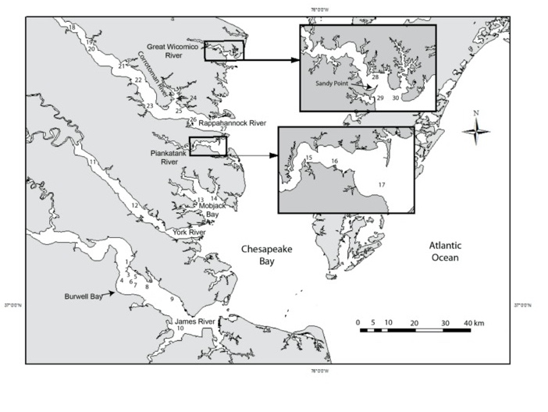

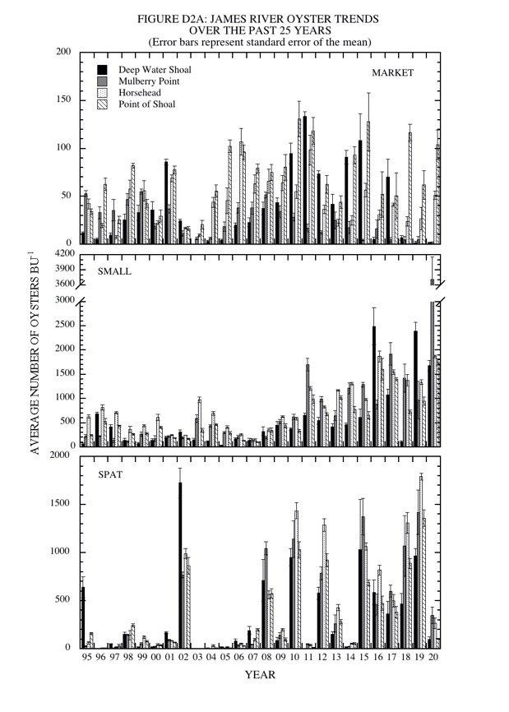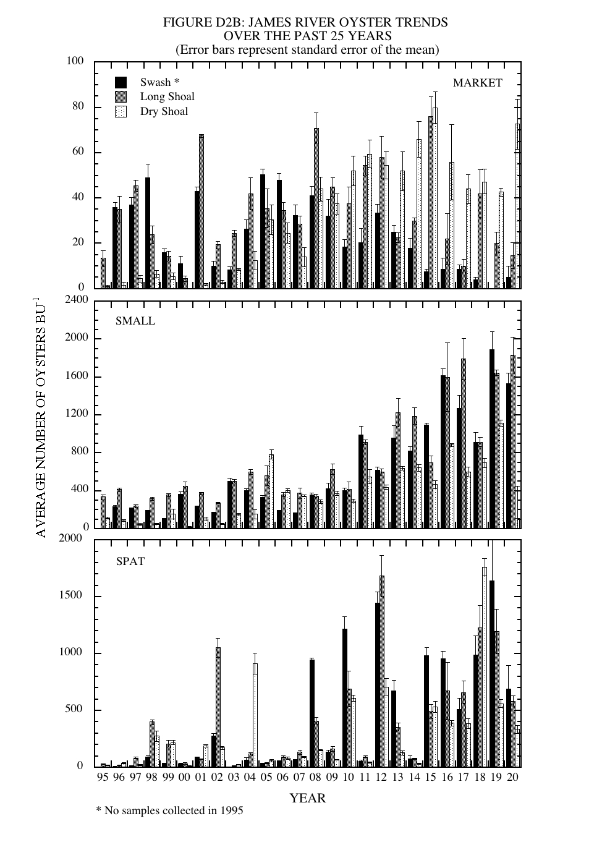

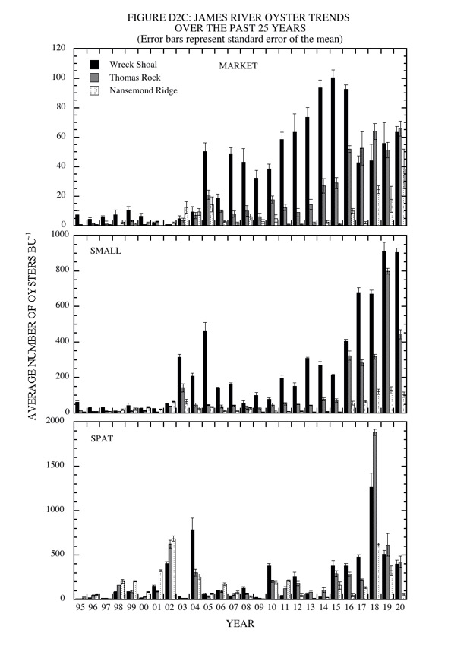

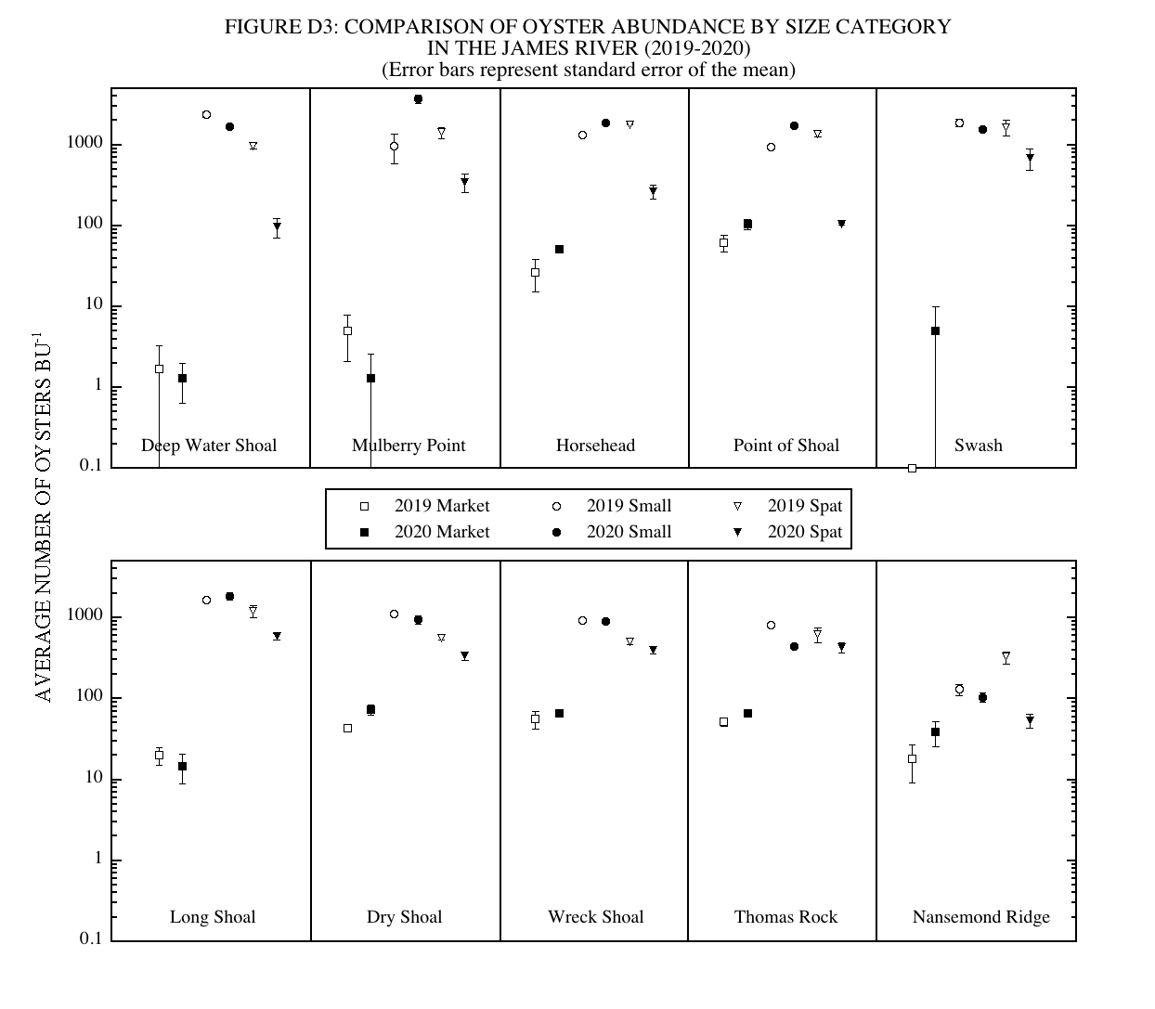

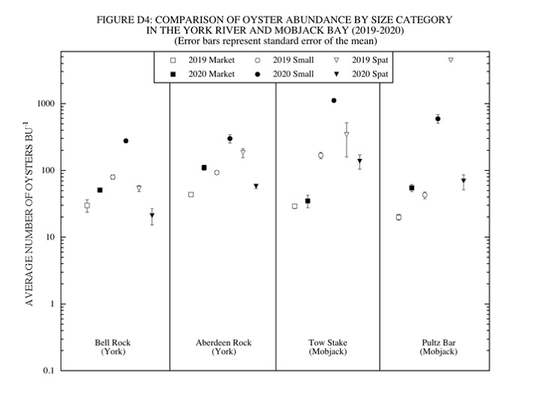

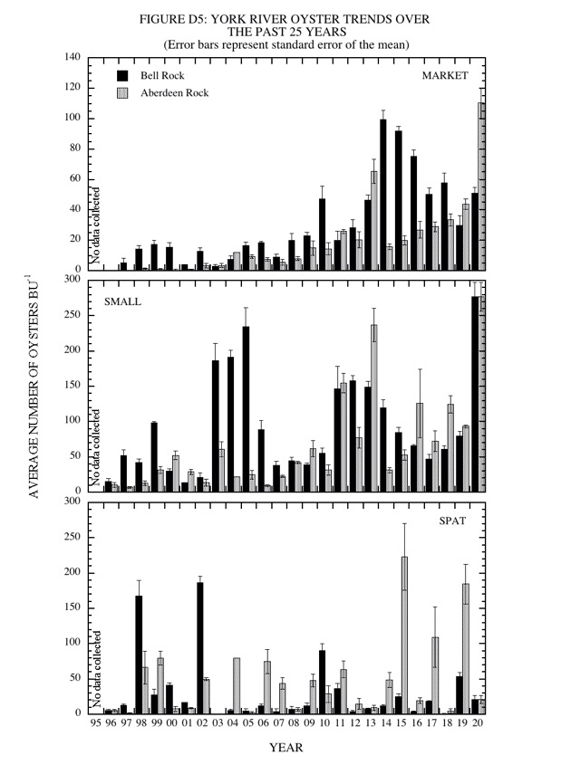

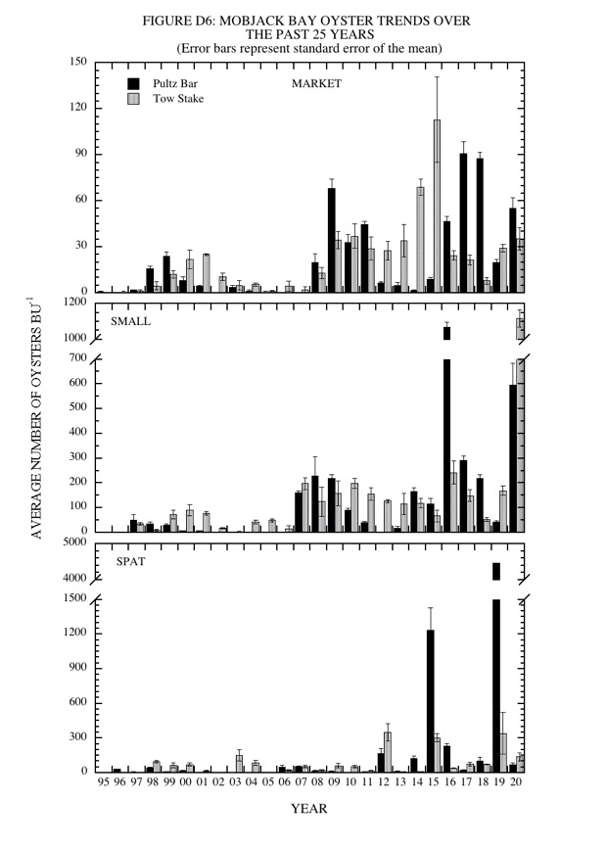

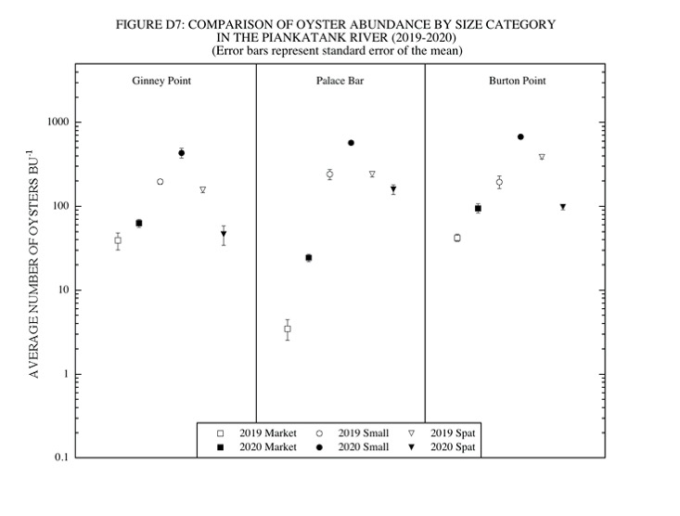

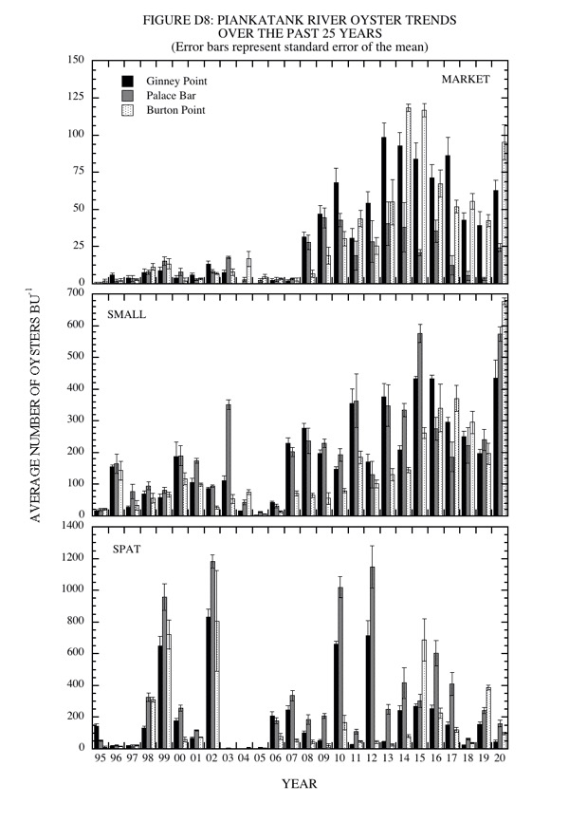

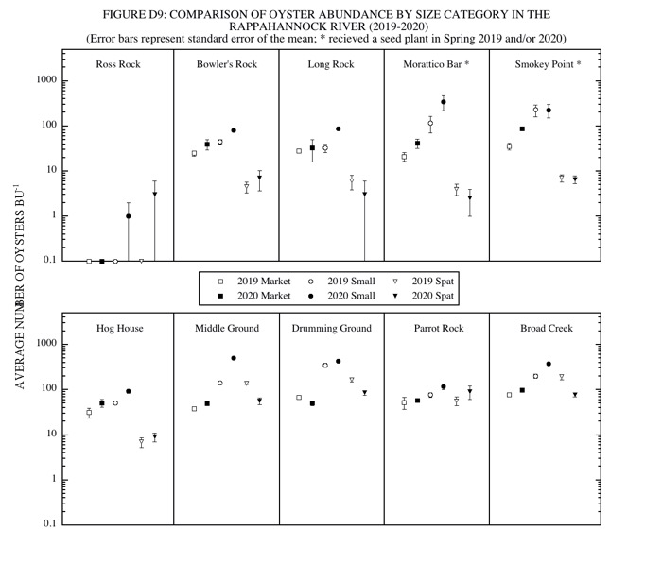

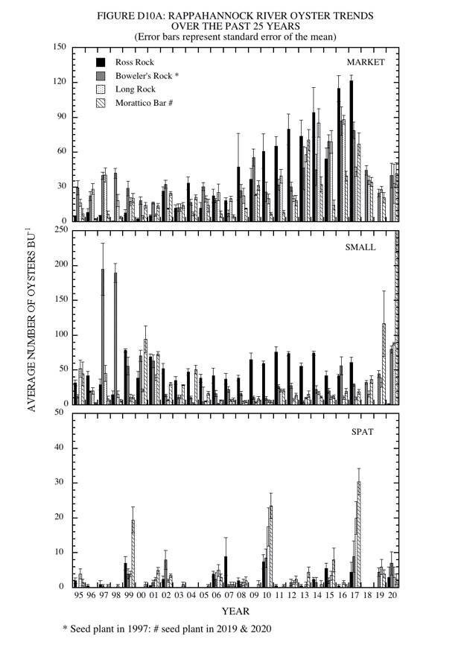

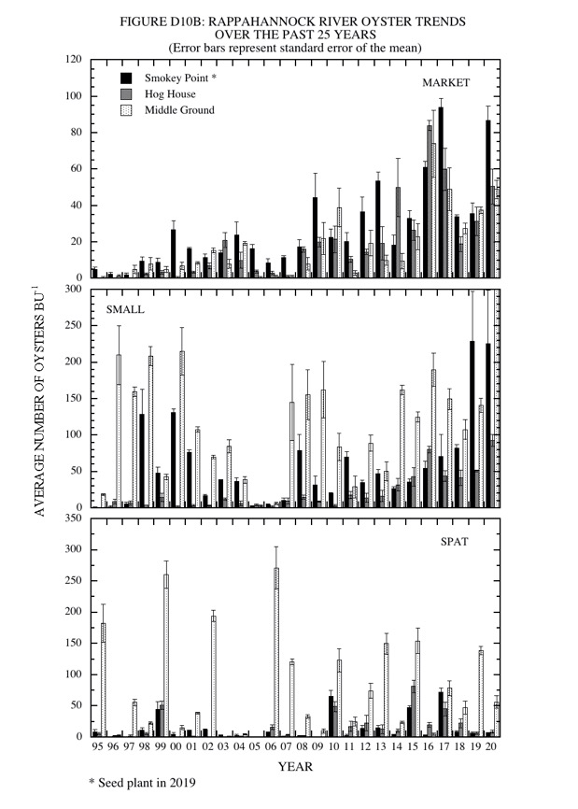

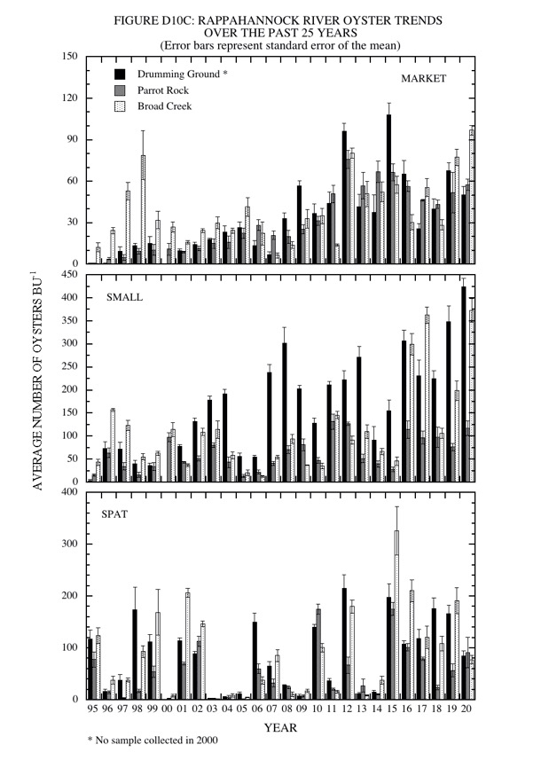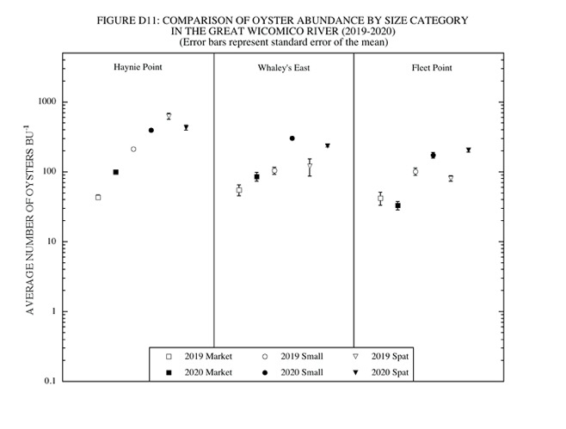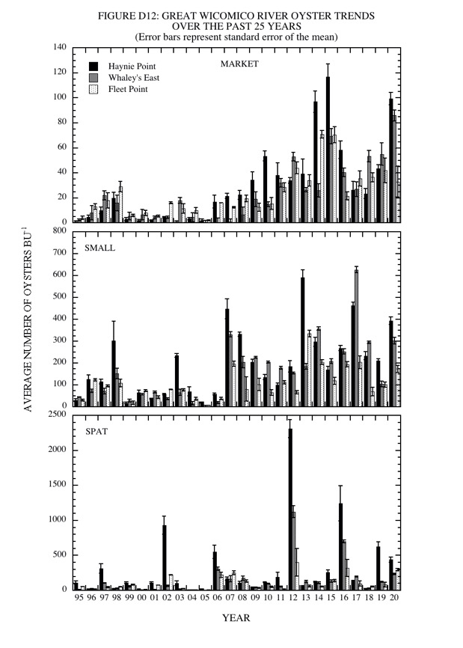

ACKNOWLEDGMENTS

These monitoring programs required the assistance of many people, without whose contributions they could not have been successfully completed. We are deeply grateful to the following: Nathan Otto (VIMS Fisheries Science) assisted in making the shellstrings and in field collection. Alexandra Marquardt assisted in field collection. Cindy Forrester (Department of Fisheries Science, Budget Manager) and Grace Tisdale (Department of Fisheries Science, Purchasing Agents) helped with purchasing field equipment and materials. VIMS Field Operations Department provided assistance with boat scheduling and operation throughout the year, namely Raymond Forrest, Jim Goins and Terri Major. Andrew Button, Division Head, Conservation and Replenishment Division of the Virginia Marine Resources Commission provided the J. B. Baylor vessel for use during the dredge survey and assisted with data collection during the dredge survey. Vernon Rowe and William Murray of the VMRC and James Wesson provided assistance during the fall 2020 dredge survey.

REFERENCES

Baylor, J.B. 1896. Method of defining and locating natural oyster beds, rocks and shoals. Oyster Records (pamphlets, one for each Tidewater, Virginia county, that listed the precise boundaries of the Baylor Survey). Board of Fisheries of Virginia.

Carriker, M.R. 1955. Critical review of biology and control of oyster drills Urosalpinx and Eupleura. Special Scientific Report: Fisheries No. 148. 150 pp.

Hargis, W.J., Jr. & D.S. Haven. 1995. The precarious state of the Chesapeake public oyster resource. In: P. Hill and S. Nelson, editors. Proceedings of the 1994 Chesapeake Research Conference. Toward a sustainable coastal watershed: The Chesapeake experiment. June 1-3, 1994, Norfolk, VA. Chesapeake Research Consortium Publication No. 149. pp. 559-584.

Haven, D.S. 1974. Effect of Tropical Storm Agnes on oysters, hard clams, and oyster drills. In: The effects of Tropical Storm Agnes on the Chesapeake Bay estuarine system. Chesapeake Research Consortium Publication No. 27. 28 pp.

Haven, D.S. & L.W. Fritz. 1985. Setting of the American oyster Crassostrea virginica in the James River, Virginia, USA: temporal and spatial distribution. Mar. Biol. 86:271-282.

Haven, D.S., W.J. Hargis Jr. & P. Kendall. 1981. The present and potential productivity of the Baylor Grounds in Virginia. Va. Inst. Mar. Sci., Spec. Rep. Appl. Mar Sci. & Ocean Eng. No 243. 154 pp.

Mann, R., M. Southworth, J.M. Harding & J. Wesson. 2004. A comparison of dredge and patent tongs for estimation of oyster populations. J. Shellfish Res. 23(2):387-390.

Rothschild, B.J., J.S. Ault, P. Goulletquer & M. Heral. 1994. Decline of the Chesapeake Bay oyster population: A century of habitat destruction and overfishing. Mar. Ecol. Prog. Ser. 111(1-2):22-39.

Southworth, M., J.M. Harding & R. Mann. 2005. The status of Virginia’s public oyster resource 2004. Molluscan Ecology Program, Virginia Institute of Marine Science, Gloucester Point, Virginia. 51 pp.

Southworth, M. and R. Mann. 2004. Decadal scale changes in seasonal patterns of oyster recruitment in the Virginia sub estuaries of the Chesapeake Bay. J. Shellfish Res. 23(2):391-402.

Southworth, M. and R. Mann. 2016. The status of Virginia’s public oyster resource 2015. Molluscan Ecology Program, Virginia Institute of Marine Science, Gloucester Point, Virginia. 50 pp.

A number of terms are used to describe various stages of the settlement (behavior, larvae seeking the substrate), metamorphosis (irreversible change in morphology accompanying transition from larval to attached form), and subsequent growth to the juvenile (attached, small version of the adult) progression of oysters. Spat is commonly used to describe the early post metamorphic attached form. Spatfall “set” or “strike” is commonly used to describe the continuum resulting in spat. For the current report we use the common term spatfall to reflect the end point of settlement and metamorphosis on shellstrings, and recruitment to reflect survival of juvenile oysters on bottom substrate (cultch) in the following fall surveys.
https://www.vims.edu/research/units/labgroups/molluscan_ecology/archive/restoration/va_restoration_atlas/indexmap/index.php
https://www.vims.edu/research/units/labgroups/molluscan_ecology/_docs/Shellstring_manual.pdf
https://www.accuweather.com/en/us/newport-news/23606/june-weather/336210?year=2020
https://www.accuweather.com/en/us/newport-news/23606/september-weather/336210?year=2020
https://www.weather.gov/akq/MONTHLY_RAINFALL_ANALYSIS
https://webapps.mrc.virginia.gov/public/maps/chesapeakebay_map.php
The term box is commonly used to describe the articulated valves of a dead oyster. A “new” box may contain tissue from a recent mortality or simply be a set of valves with clean interior. An “old” box” is typically fouled internally. Boxes are a proxy of recent mortality, but the rates at which paired shells disarticulate is poorly understood and probably varies with size and time of year.

