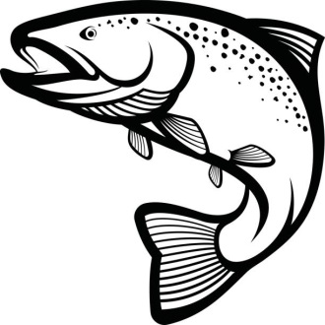
30th Chefs’ Seafood Symposium Agenda
March 14, 2023 @ Virginia Inst. of Marine Science
Cosponsored by Virginia Sea Grant Marine Extension Program, Virginia Institute of Marine Science Marine Advisory Services, ACF Virginia Chefs Association

8:30 am Registration Opens
9:05 am Welcome & Introduction
Lisa Lawrence, VIMS Marine Advisory Program & Dr. Dave Rudders, Associate Director
Marine Advisory Services, VIMS
9:05 am Virginia Chefs Association Update
9:15 am Blue Crabs
Rom Lipcius, VIMS Fisheries Science
9:45 am Seagrass Science & Eelgrass Beer
Chris Patrick, VIMS Biological Sciences & Spenser Jett, Väsen Brewing Co.
10:20 am Seafood Safety & Blue Catfish Update
Katheryn Parraga-Estrada, Virginia Seafood Agricultural Research and Extension Center
10:50 am Break
11:00 am Commercial Fishery Update & BayDirect Seafood App
Sarah Borsetti, VIMS Marine Advisory Program & Stephanie Heinatz, Consociate Media
11:30 am Seafood Restaurant Marketing
Michael Kimball, Consociate Media
12:00 pm Lunch
1:00 pm Seafood Cooking Demonstration
Guest Chef TBD
2:00 pm Wrap-up & Adjourn
2:15 pm VIMS Tour (optional, registration required)
3:30 pm VIMS Tour Ends

